Figure S1: -log(P-value) plotted against the position of variants detected by GWAS (in grey) and conditional GWAS (GWAS_COJO; in blue)
a) On BTA1, in Montbéliarde analysis for the αs1-CN phenotype, with the fixed effect of
a1) the TOP1 variant detected in within-breed Montbéliarde GWAS, at 144,397,274 bp
a2) the TOP1 variant detected in multibreed GWAS, at 144,398,814 bp
a3) the most probable candidate variant detected by Kemper et al (2015), at 144,414,936 bp, ranked 101st in multibreed GWAS
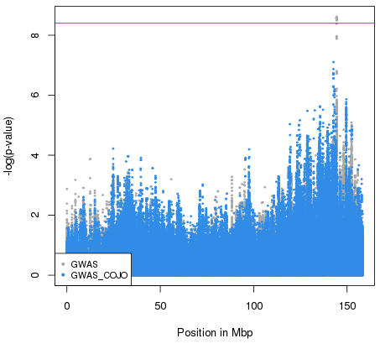
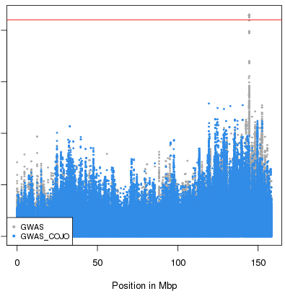
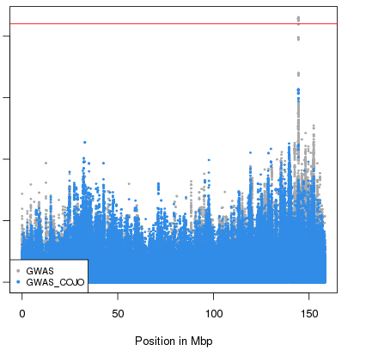
a1)
a3)
a2)

b) On BTA2, in Montbéliarde, Normande, and Holstein analyses for the αs2-CN phenotype, with the fixed effect of the TOP1 intronic variant detected in the within-breed Normande GWAS, at 131,806,882 bp
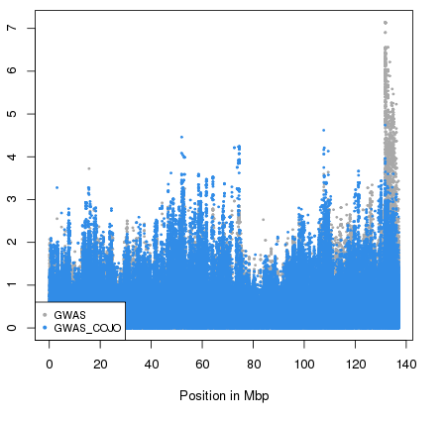
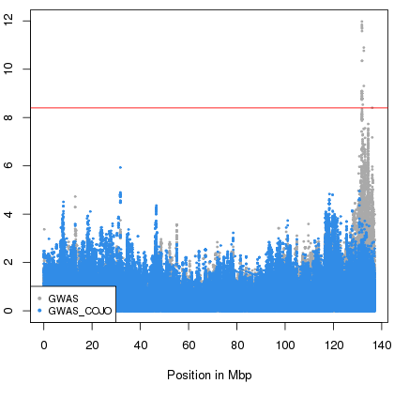
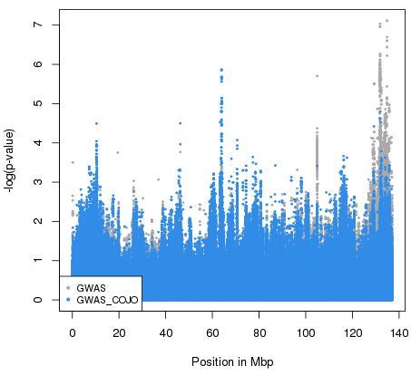
Montbéliarde
Holstein
Normande

c) On BTA5, in Holstein analysis for the PC phenotype, with the fixed effect of
c1) the TOP1 upstream variant detected in the multi-breed GWAS, at 93,950,211 bp
c2) the TOP2 5’-UTR or TOP3 upstream variants detected in the multi-breed GWAS, at 93,950,116 and 93,950,288 bp
c3) the upstream variant detected by Raven et al. (2015) at 93,951,731 bp and ranked 23rd in the multi-breed GWAS
c4) the intronic variant detected by Iso-Touru et al. (2016) at 93,945,694 bp, outside of the confidence interval of the QTL detected in the multi-breed GWAS
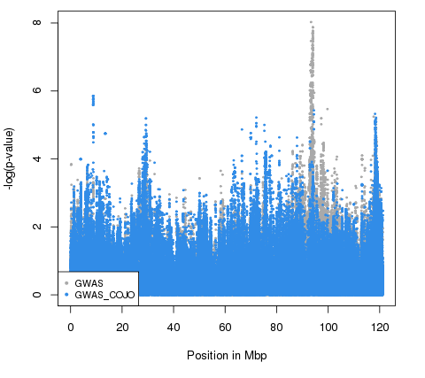
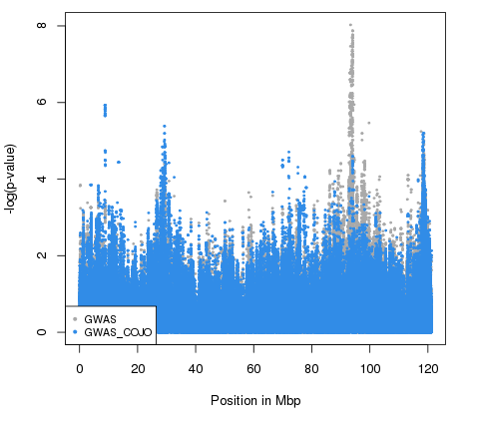
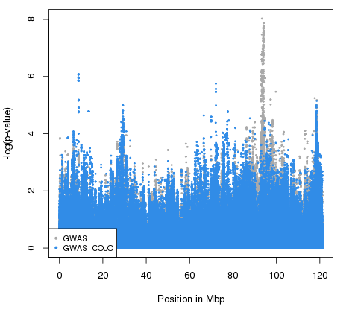
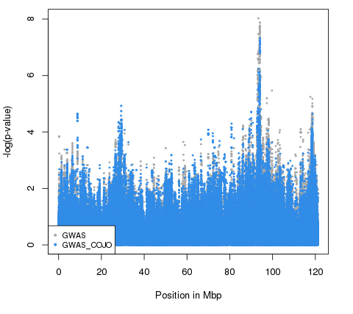
c2)
c1)

c4)
c3)

d) On BTA11, in Montbéliarde, Normande, and Holstein analyses for the β-LG phenotype, with the fixed effect of
d1) the missense PAEP mutations that cause the A and B protein variants, at 103,303,475 and 103,304,757 bp (Ganai et al., 2009)
d2) the upstream PAEP variant (103,298,431 bp) ranked in the TOP6 in within- and multi-breed analyses

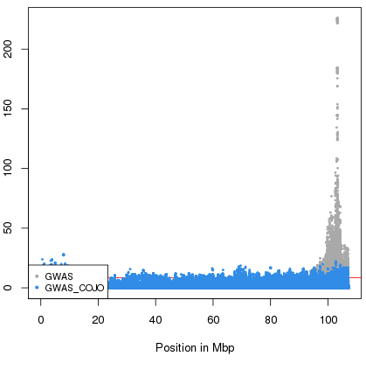
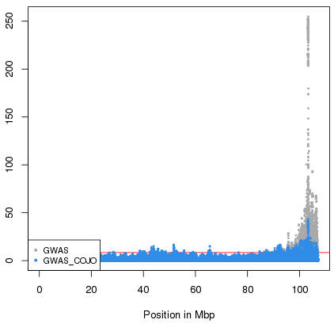
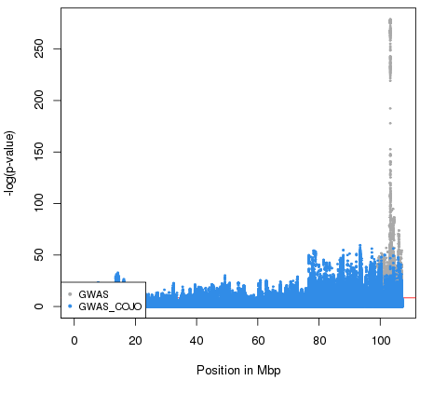
d1)
Holstein
Normande
Montbéliarde

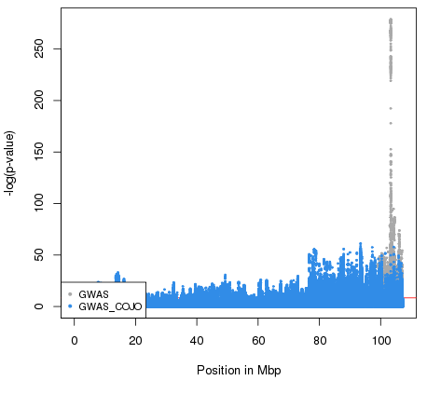
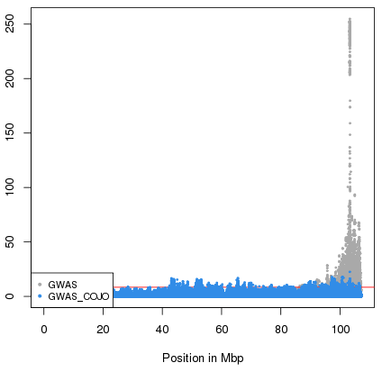
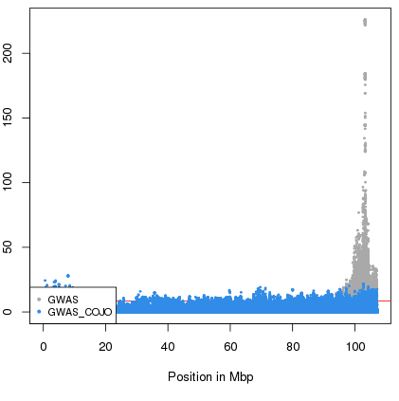
d2)
Montbéliarde
Holstein
Normande

e) On BTA14, in Normande and Holstein analyses, with the fixed effect of
e1) the causative K232A DGAT1 variant for the κ-CN phenotype, at 1,802,266 bp (Grisart et al., 2001)
e2) the missense BOP1 variant (1,842,678 bp), ranked 1st in the NOR analysis for the κ-CN phenotype
e3) one of the three missense RECQL4 variants in complete LD (1,617,841, 1,618,978, and 1,619,555 bp), ranked 3rd in the HOL analysis for the κ-CN phenotype
e4) the missense MROH1 variant (1,878,165 bp), ranked 14th in the HOL analysis for the αs2-CN phenotype
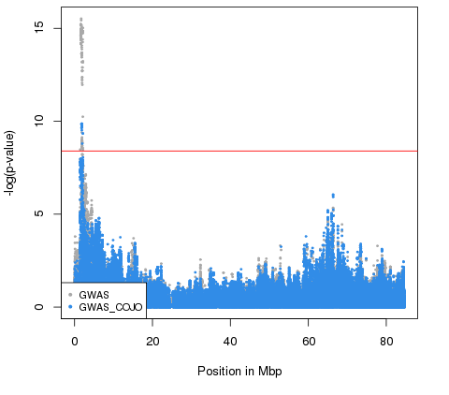
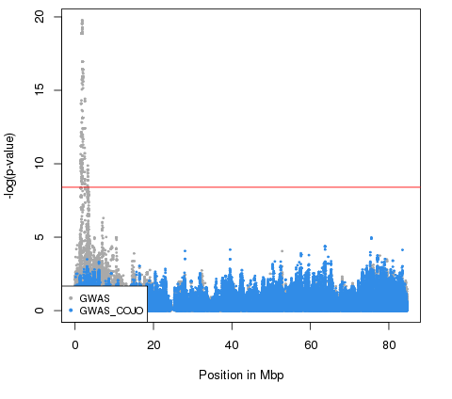
e1)
Holstein
Normande

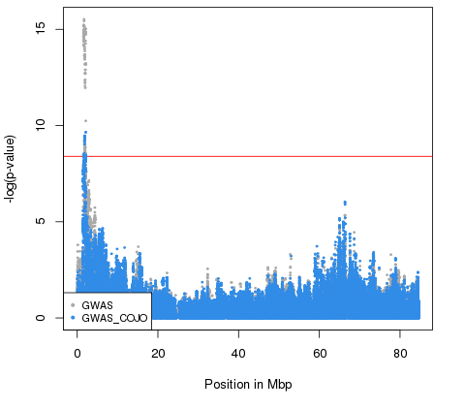
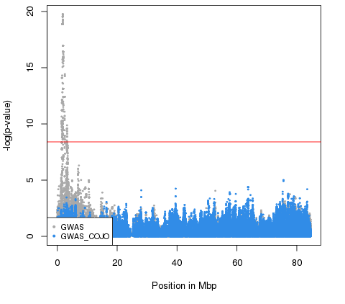
e2)
Normande
Holstein

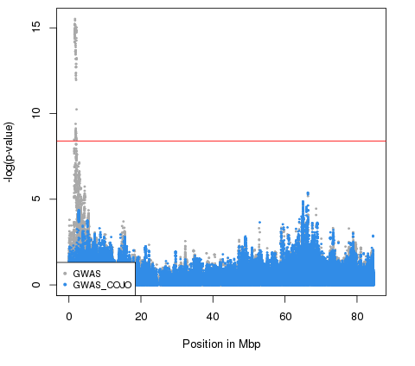
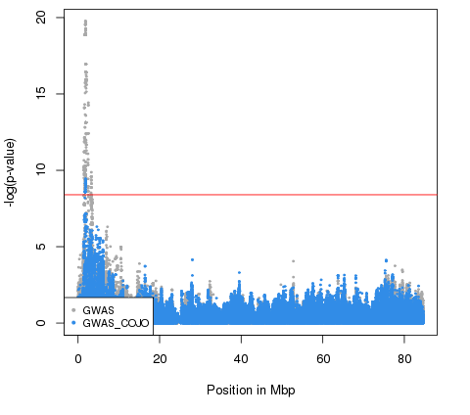
e3)
Normande
Holstein

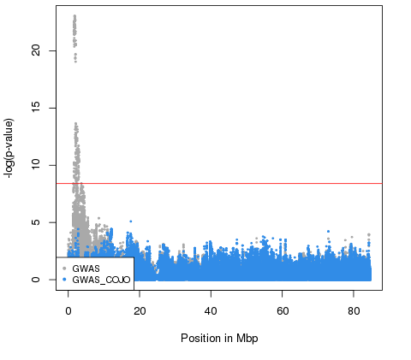
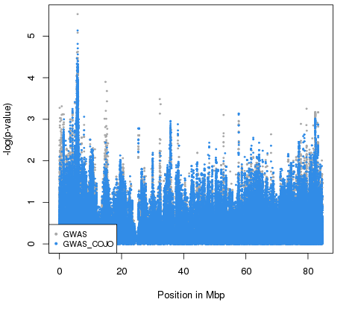
e4)
Normande
Holstein

f) On BTA20, for the α-LA phenotype, with the fixed effect of the most significant variant, located in the ANKH gene in Montbéliarde (58,446,550 bp), Normande (58,422,697 bp), and Holstein (58,491,204 bp) analyses
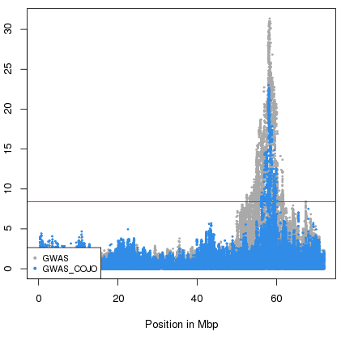
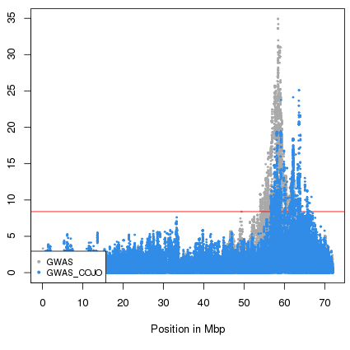
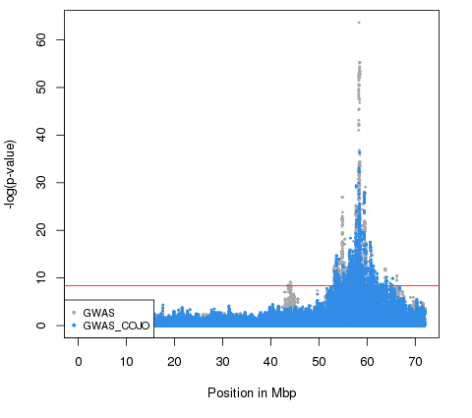
Holstein
Normande
Montbéliarde

g) On BTA27, for the κ-CN phenotype, with the fixed effect of one of the five most significant variants located in the AGPAT6 gene (36,209,319, 36,211,252, 36,211,258, 36,211,708, and 36,212,352 bp) in Montbéliarde, Normande, Holstein, and multi-breed analyses
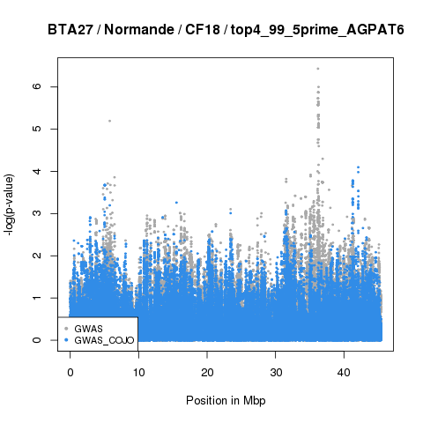
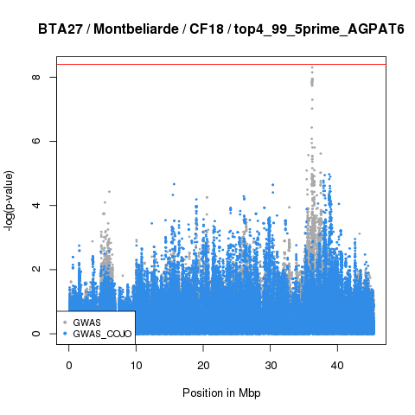

Normande
Montbéliarde

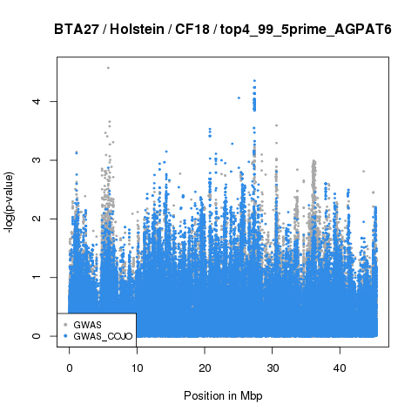
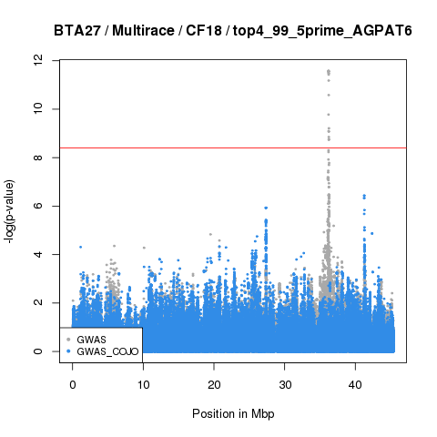

Holstein
Multi-breed

h) On BTA29, in Montbéliarde, Normande, and Holstein analyses for the αs1-CN phenotype, with the fixed effect of
h1) the intronic PICALM variants, at 9,651,065 and 9,656,439 bp, ranked 11th in the MON analysis
h2) the upstream PICALM variant, at 9,611,304 bp, ranked 10th in the HOL analysis
